## **Course challenge**

**Question 1**

**Scenario 1, Questions 1-7**

For the past six months, you have been working for a direct-mail marketing firm as a junior marketing analyst. Direct mail is advertising material sent to people through the mail. These people can be current or prospective customers, clients, or donors. Many charities depend on direct mail for financial support.

Your company, Directly Dynamic, creates direct-mail pieces with its in-house staff of graphic designers, expert mail list services, and on-site printing. Your team has just been hired by a local nonprofit, Food Justice Rock Springs. The mission of Food Justice Rock Springs is to eliminate food deserts by establishing local gardens, providing mobile pantries, educating residents, and more. Click below to read the email from Tayen Bell, vice president of marketing and outreach.

The client has asked you to send two separate mailings: one to people within 50 miles of Rock Springs; the other to anyone outside that area. So, to research each donor’s distance from the city, you first need to find out where all of these people live.

You could scroll through 209 rows of data, but you know there is a more efficient way to organize the cities.

**Which of the following tools will enable you to sort your spreadsheet by city (Column K) in ascending order?**

Sort Sheet by Column K from Z to A

Sort Range by Column K from A to Z

**Sort Sheet by Column K from A to Z**

Sort Range by Column K from Z to A

**Correct**

To sort your spreadsheet by city in ascending order, Sort Sheet by Column K from A to Z. You can also use the SORT function syntax =SORT(A2:R210, 11, TRUE).

**Question 2**

**Scenario 1, continued**

You notice that many cells in the city column, Column K, are missing a value. So, you use the zip codes to research the correct cities. Now, you want to add the cities to each donor’s row. However, you are concerned about making a mistake, such as a spelling error.

**What spreadsheet tool can you use to add a drop-down list with predetermined options for each city name?**

List

**Data validation**

Find

VLOOKUP

**Correct**

You use data validation to add drop-down lists with predetermined options for each city name. This allows you to control what can and cannot be entered in your worksheet.

Question 3

**Scenario 1, continued**

Now, you decide to address Tayen’s request to include a handwritten note in the direct-mail piece for anyone who gave at least $100 last year.

**Which of the following spreadsheet tools will enable you to change how cells appear if they contain a value of $100 or more?**

The COUNTA function

Data validation

**Conditional formatting**

The MAX function

**Correct**

To change how cells appear, use conditional formatting. Choose to format cells if they are greater than or equal to 100.

**Question 4**

**Scenario 1, continued**

At this point, you notice that the information about state and zip code is in the same cell. However, your company’s mailing list software requires states to be on a separate line from zip codes.

**What function will enable you to move the 2-character state abbreviation in cell L2 into its own column?**

=LEFT(2,L2)

=RIGHT(2,L2)

=RIGHT(L2,2)

**=LEFT(L2,2)**

**Correct**

To move the 2-character state abbreviations in Column L into their own column, use the LEFT function: =LEFT(L2,2).

Question 5

**Scenario 1, continued**

Next, you duplicate your dataset twice using the Sheet Menu. You rename the first sheet Donation Form List, and you remove the cities that are further than 50 miles from Rock Springs. You rename the second sheet Postcard List, and you remove the cities that are within 50 miles of Rock Springs.

Then, you import these datasets into your company’s mailing list database. In a mailing list database, you create two tables: Donation_Form_List and Postcard_List. You decide to clean the Donation_Form_List first.

Your company’s mailing list software requires units to be on the same line as street addresses. However, they are currently in two separate columns (street_address and unit).

**You use a SQL function to instruct the database to combine the two columns into a new column called “address.” The syntax is: JOIN(street_address, " to ", unit) as address.**

True

**False**

**Correct**

To combine the two columns into a new column called “address,” the syntax is: CONCAT(street_address, " to ", unit) as address.

**Question 6**

**Scenario 1, continued**

Your database contains people who live in many areas of Wyoming. However, it’s important to align your in-house data with the data from Food Justice Rock Springs. You also need to separate your data into the two lists: Donation_Form_List and Postcard_List. They will be based on each city’s distance from Rock Springs.

**What SQL function do you use to select all data from the Donation_Form_List organized by zip code?**

**ORDER BY**

SEQUENCE

ORGANIZE

ARRANGE BY

**Correct**

To select all data from the Donation_Form_List organized by zip code, you use the ORDER BY function. The ORDER BY function sorts results returned in a query.

**Question 7**

You finish cleaning your datasets, so you decide to review Tayen’s email one more time to make sure you completed the task fully. It’s a good thing you checked because you forgot to identify people who have served on the board of directors or board of trustees. She wants to write them a thank-you note, so you need to locate them in the database.

**To retrieve only those records that include people who have served on the board of trustees or on the board of directors, what clause do you include in your query?**

WHERE Board_Member = TRUE, Trustee = TRUE

**WHERE Board_Member = "TRUE" OR Trustee = "TRUE"**

WHERE Board_Member = "TRUE" AND Trustee = "TRUE"

WHERE Board_Member = TRUE AND Trustee = TRUE

**Correct**

To retrieve only those records that include people who have served on the board of trustees or on the board of directors, the correct query is:

Question 8

**Scenario 2, Questions 8-13**

Your company’s direct-mail campaign was very successful, and Food Justice Rock Springs has continued partnering with Directly Dynamic. One thing you’ve been working on is assigning all donors identification numbers. This will enable you to clean and organize the lists more effectively.

Meanwhile, another team member has been creating a prospect list that contains data about people who have indicated interest in getting involved with Food Justice Rock Springs. These people are also assigned a unique ID. Now, you need to compare your donor list with the dataset in your database and collect certain data from both.

**What SQL function will return all records from the left table and only the matching records from the right?**

OUTER JOIN

**LEFT JOIN**

RIGHT JOIN

INNER JOIN

**Correct**

A LEFT JOIN function will return all records from the left table and only the matching records from the right.

**Question 9**

**Scenario 2, continued**

Your next task is to identify the average contribution given by donors over the past two years. Tayen will use this information to set a donation minimum for inviting donors to an upcoming event.

**You have performed the calculations for 2019, so now you move on to 2020. To return average contributions in 2020 (contributions_2020), you use the AVG function. You use the following section of a SQL query to find this average and store it in the AvgLineTotal variable:**

|  |
| --- |
| AVG(contributions_2020) AS AvgLineTotal |

**True**

False

**Correct**

To return average contributions in 2020, the correct portion of the SQL query is:

|  |
| --- |
| AVG(contributions_2020) AS AvgLineTotal |

**Question 10**

**Scenario 2, continued**

Now that you provided her with the average donation amount, Tayen decides to invite 50 people to the grand opening of a new community garden. You return to your New Donor List spreadsheet to determine how much each donor gave in the past two years. You will use that information to identify the 50 top donors and invite them to the event.

**What is the correct syntax to add the contribution amounts in cells O2 and P2?**

=SUM(O2*P2)

=SUM(“O2,P2”)

=SUM(O2/P2)

=SUM(O2,P2)

**Correct**

To add cells O2 and P2, use the function =SUM(O2,P2). You can also use the formula =O2+P2.

**Question 11**

**Scenario 2, continued**

Tayen informs you that she’s thinking about inviting anyone who donated at least $100 in 2018, as well. However, she only has five open spaces. She asks you to report how many people gave at least $100 so she can determine if they can also be invited to the event.

**What is the correct syntax to count how many donations of $100 or greater appear in Column O (Contributions 2018)?**

=COUNTIF(O2:O210">=100")

**=COUNTIF(O2:O210,">=100")**

=COUNTIF(O2:O210,>=100)

=COUNTIF(O2:O210>=100)

**Correct**

To count how many donations of $100 or greater appear in Column Q, the correct syntax is =COUNTIF(O2:O210,">=100").

**Question 12**

**Scenario 2, continued**

The community garden grand opening was a success. In addition to the 55 donors Food Justice Rock Springs invited, 20 other prospects attended the event. Now, Tayen wants to know more about the donations that came in from new prospects compared to the original donors.

**This SQL query can be used to identify the percentage of contributions from prospects compared to total donors:**

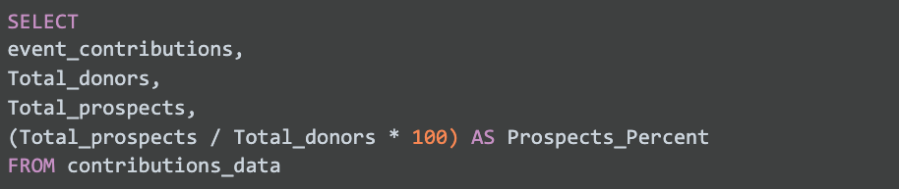

**True**

False

**Correct**

The correct query is:

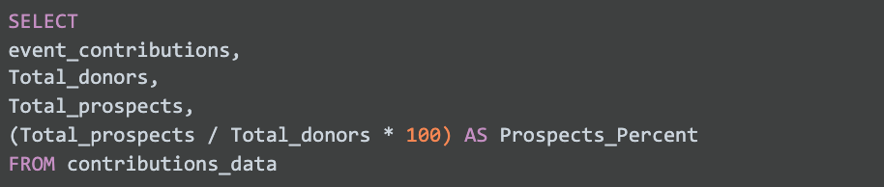

**Question 13**

**Scenario 2, continued**

Your team creates a highly effective prospects list for Food Justice Rock Springs. After a few months, many of these prospects become donors. Now, Tayen wants to know the top three cities in which these new donors live. She will use that information to determine if it’s still true that people who live closer to Rock Springs are more likely to donate.

**Which SQL query will retrieve the number of donors in each city, sorted high to low?**

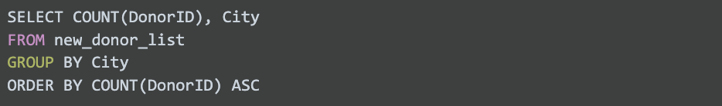SELECT COUNT (DonorID), City FROM new_donor_list GROUP BY City ORDER BY COUNT (DonorID) ASC

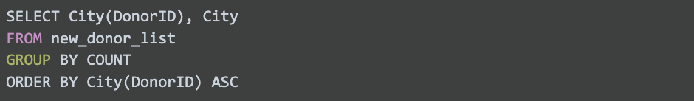**SELECT City (DonorID), City FROM new_donor_list GROUP BY COUNT ORDER BY City (DonorID) ASC**

